Remote Sensing Approach for Classifying Invasive Species at the Ma’lel Dunes between 2018-2019 to Facilitate Control Measures

Asinn Kim, Cameron Colgan, Jeremy Dustin, Preston Heen, Riley Harte

**Abstract**Westof the Humboldt Coastal Nature Center in Manila, California are the Ma-le'l Dunes. Said dunes have been contending with the rapid spread of invasive plants including but not limited to European beachgrass (*Ammophila arenaria*), Iceplant (*Carpobrotus chilensis* and *Carpobrotus edulis*), and Yellow Bush Lupine (*Lupinus arboreus*). In this paper we explain our study and mapping of these plants' growth and locations. This study will help with the removal of invasive species and keeping watch on their progress over the years to come for better prediction of their future movements

**Introduction**This study was conducted in order to identify invasive plant species in the Ma’lel Dunes near Humboldt Bay, California. We used an Unmanned Aerial Vehicle to collect images that we could classify. Training data was used to support classifications, and we were able to identify invasive plant species. Some of the invasive plants species identified were European beachgrass (*Ammophila arenaria*), Iceplant (*Carpobrotus chilensis* and *Carpobrotus edulis*), and Yellow Bush Lupine (*Lupinus arboreus*).

These invasive plant species pose a threat to the sensitive and dynamic habitat of the Ma’lel Dunes ecosystem by outcompeting and taking up space that native plant species need to grow, upon which native fauna rely on for food and shelter (Nystrom, 2018). They also alter the chemistry of the sandy soils and the physical dynamics of the shifting sand dune system. Specifically, Carpobrotus (Iceplant) increases the soil salinity where it grows and makes the soil inhospitable to other plants. Ammophila (European beachgrass) creates tall, steep, and very stable foredunes (above the flat wave slope of the beach) that blocks windblown sand particles from reaching and building the middle dunes, and prevents the shifting of these dunes that native plant species require and are adapted to (Nystrom, 2018). Native plants rely on gently sloping, rounded, shorter dunes with some disturbance for survival and reproduction.

**Methods**

To identify non-native species in the area of interest we utilized maximum likelihood classification in ArcMap Version 10.5.1 with a mosaiced orthoimage taken using UAV technology. Classification is a remote sensing data analysis technique that works to identify specific types of land cover based on spectral information in raster datasets. Maximum likelihood classification compares the variances and covariances of spectral signature classes developed from digitized training data. The output is a classified image from raster bands, and it can be used to see the area of invasive versus native species. When creating our training dataset, ground truth data was obtained to identify specific land cover types in the field, which improved the development of training classes. Training samples for each class improves the accuracy of the classification.

In addition to the training data, the RGB and NIR bands of the orthoimage were used to calculate the texture analysis for Normalized Difference Vegetation Index (NDVI) with the intention of improving the vegetation classification. Using the Raster Calculator in ArcMap we will calculate the NDVI from the individual Red and NIR bands.

NDVI = 1.0 * (NIR – RED)

(NIR + RED)

The mean and standard deviation of the NDVI Raster was then calculated by using the Focal Statistics tool in ArcMap. A raster was then created for texture analysis which will incorporate all the bands together to make a composite. The Composite Bands tool were used to combine both original RGB/NIR orthoimage, the NDVI mean, and the NDVI Standard Deviation into a single raster, which was then clipped to the extent of the study area available.

For the supervised classification, training sample areas were created using the ArcMap tool “Training Sample Manager”, to train the program on a few specific vegetation and land cover types.Training samples were broken down into native and non-native vegetation, wood, sand, and shadow classification types, to generate a signature file of the sample areas. Using the training shadow classification types, to generate a signature file of the sample areas. Using the training sample signature file, the “Maximum Likelihood Classification” tool was used to classify vegetation based on just the RGB ortho-image, and then ran again using the newly created NDVI texture composite ortho-image. After this was ran, we selected a reasonable study site to clip the image to, and to show a certain area that is fully infested with invasive plants. The two output classification images that were created were then color coded and compared to determine which method classified invasive vegetation best.

**Results**

We mapped the dominant invasive/native species to compare the differences between the year 2018-2019 within a subplot of dune habitats (Figure 1&2) using image classification techniques. Of the species European beachgrass (*Ammophila arenaria*) (1), Iceplant (*Carpobrotus chilensis)* (2) , and Yellow Bush Lupine (*Lupinus arboreus*) (3), European beach grass outcompetes with other species and is widely distributed across the dunes in both 2018-2019.

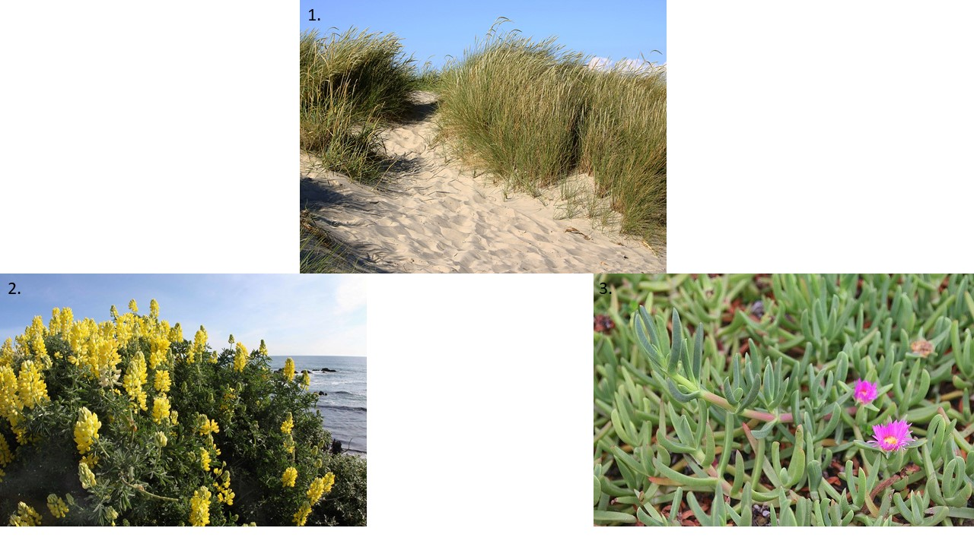

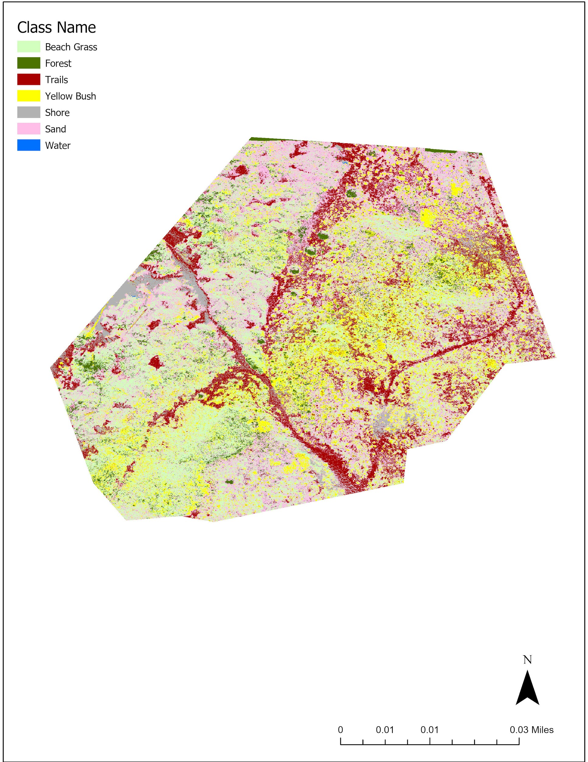

*Figure 1: Results of supervised maximum likelihood classification incorporating 2019 UAV data*

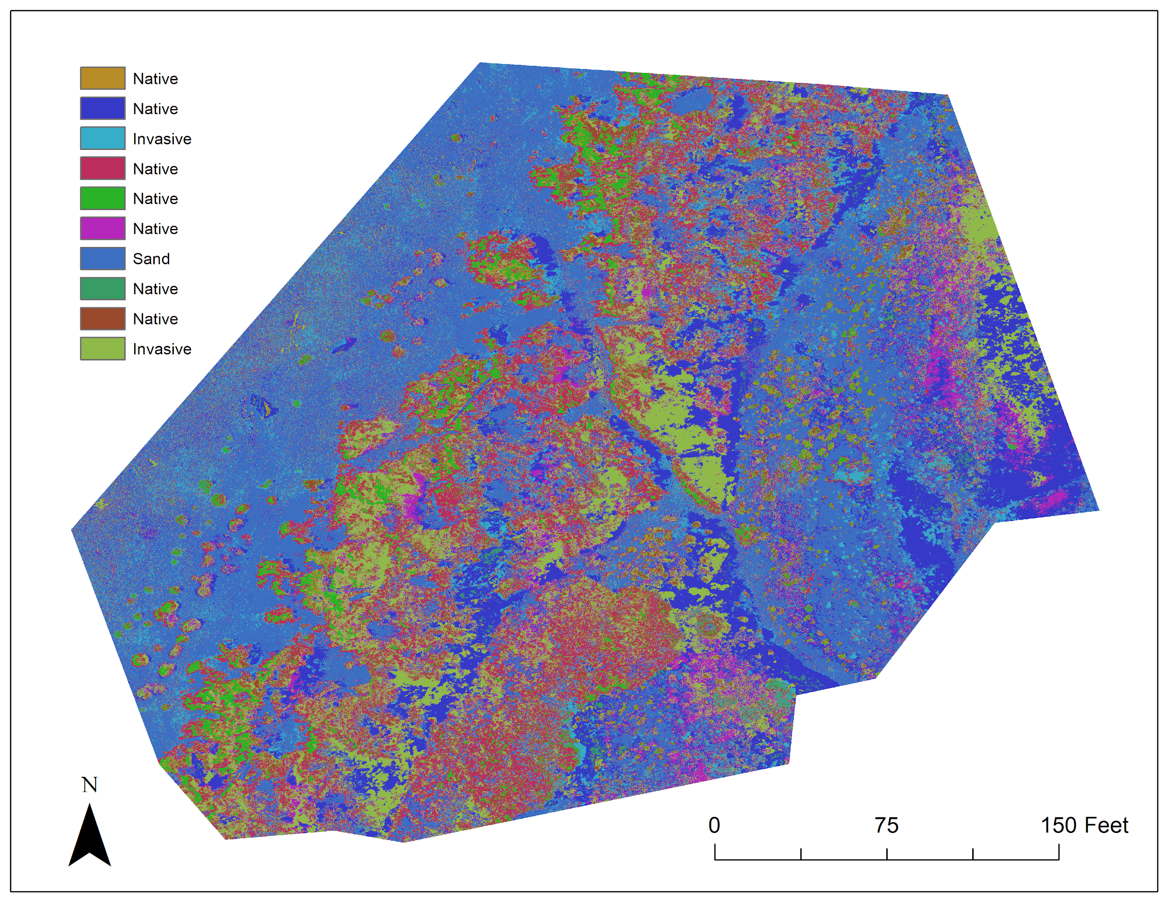

*Figure 2: Results of supervised maximum likelihood classification incorporating 2018 UAV data*

**Conclusion**The efforts of locals to rid the beaches of invasive plants through removal has not been in vain, but the invasive plants are still dominating the dunes and preventing local plants from growing where they need to grow in order to preserve the dunes' natural shapes. When the plants grow on top of the dunes, they immobilize the sand and prevent the natural shift and flow of the dunes formation, and outcompete the local plants for the natural resources. That said, the efforts of local people to remove the invasive plants has prevented the full domination of invasive plants and has allowed some of the younger native plants to get firm roots before having to contend with the other plant life. There has not been a large change in the amount of beach surface that invasive species cover between 2018 and 2019, but we can still see that certain areas are still being dominated by the presence of invasive plants and their growth across the dunes.

**References**

1. Nystrom, S. (2018, November 8). Ecology and Restoration of California's Coastal Dune Habitat. Retrieved December 6, 2019, from <http://natural-history-journal.blogspot.com/2017/05/ecology-and-restoration-of-californias.html>.
2. Ma-le'l Dunes CMA. Retrieved November 22, 2019, from<https://www.blm.gov/visit/ma-lel-dunes>.
3. Creutzburg, M. K. (2012, January 5). Supervised Classification. Retrieved November 22, 2019, from<https://wiki.landscapetoolbox.org/doku.php/remote_sensing_methods:supervised_classification>.
4. Western Snowy Plover - Humboldt Bay - U.S. Fish and Wildlife Service. Retrieved November 22, 2019, from<https://www.fws.gov/refuge/Humboldt_Bay/wildlife_and_habitat/WesternSnowyPlover.html>